**The Journey :**

**(Song)**

**1st Verse :**

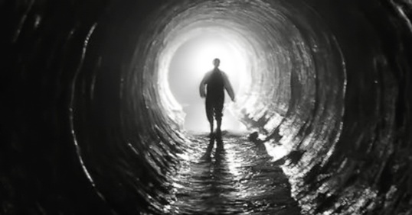In the darkness, we search the light,

An endless Journey throught the night.

Chasing dreams of the American dream,

A land of hope, or so it seems

**2nd Verse :**

Throught the waves of the oceans wide,

To Ellis Island, dreams collide.

Seeking freedom, a brand new start,

With love and peace within each heart.

**Chorus :**

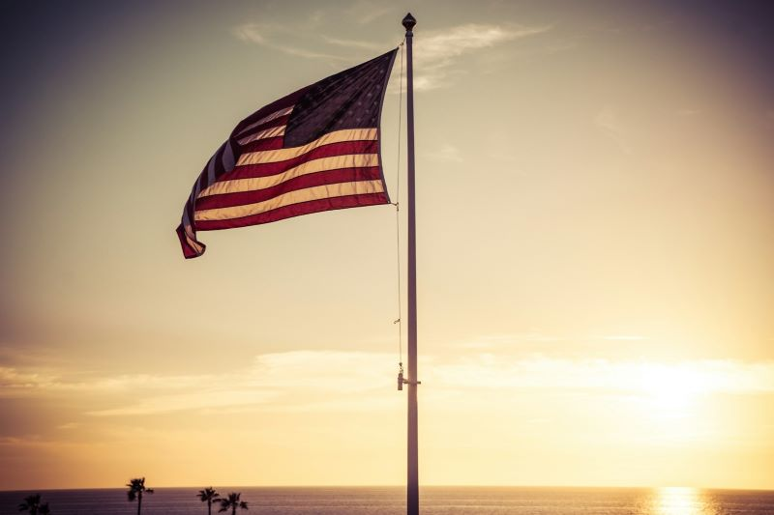American dream, shining so bright,

Freedom’s call in the dead of night,

With hope in our heart, we rise above,

To a land of promise, we move with love !

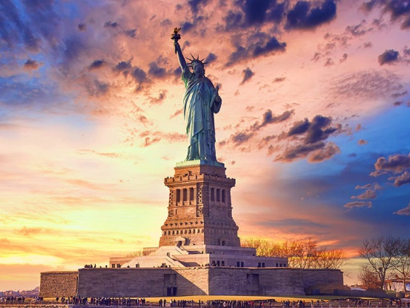**3rd Verse :**

In New York‘s glow, the city lights,

A symbol of hope through darkest nights.

The statue of liberty,

Show me that i find the freedom quickly

**4th Verse :**

Throught mountains high and valleys deep,

We seek a future, our promises to keep.

Optimistic visions in our sight,

A land of freedom, our guiding light.

**Chorus :**

American dream, shining so bright,

Freedom’s call in the dead of night.

With hope in our hearts, we rise above,

To a land of promise, we move with love !