
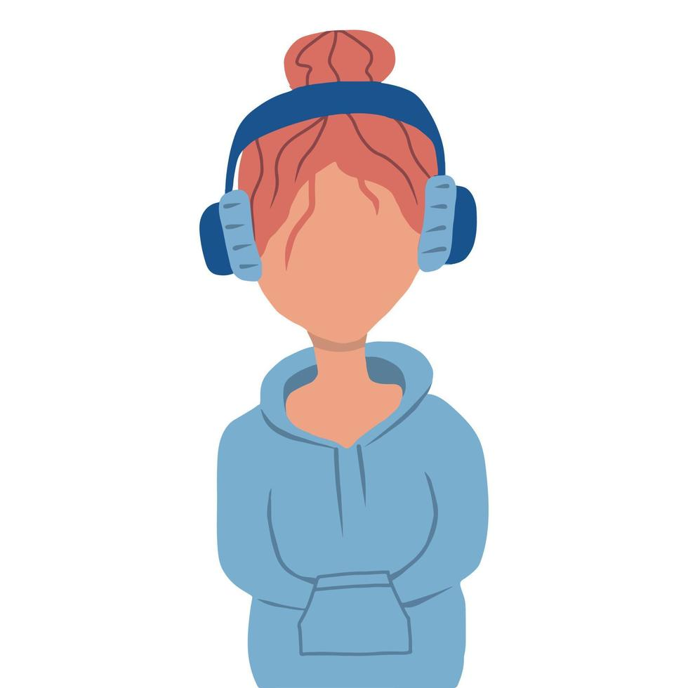

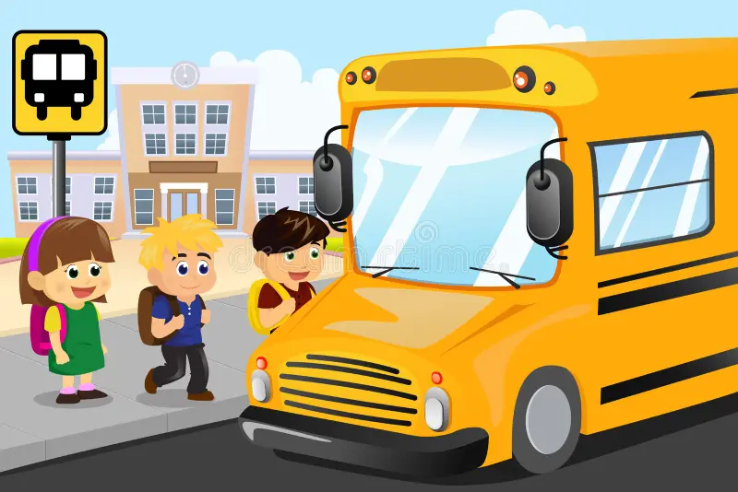
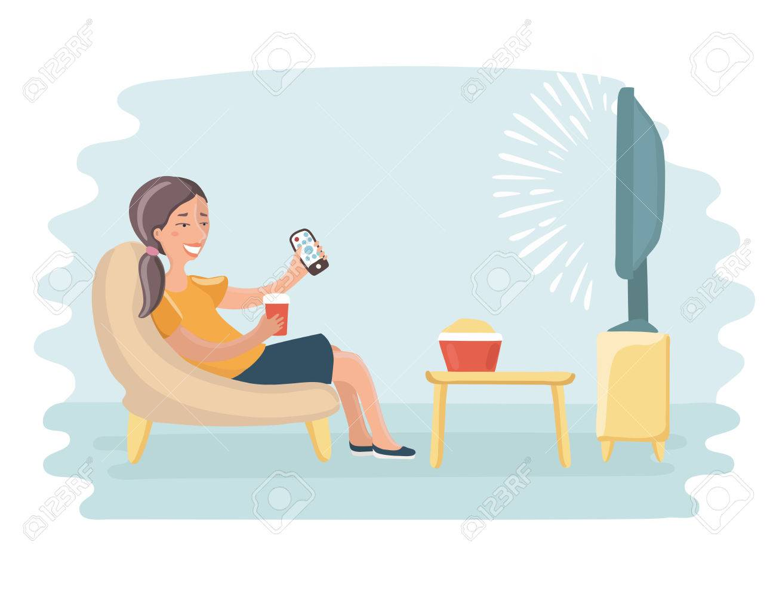
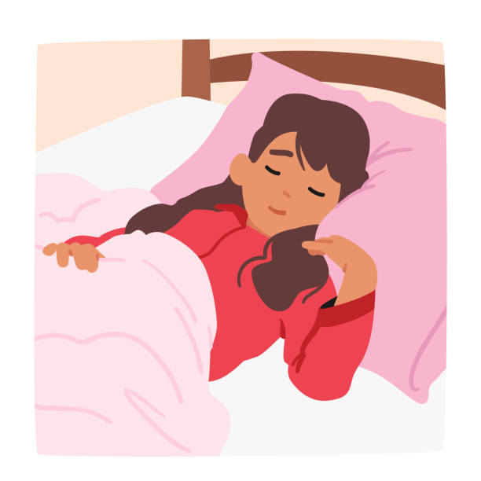
I usually wake up at 7am.
I always brush my teeth
I often take my snack at 4 pm.I usually eat at 8 pm and often sleep at 10:30 pm.
I usually go back to
school at 1:30p:m
and I often
listen to music on my way.
Elyna’s
routine
I always eat at home by 12 pm and I often watch TV.
I often go to school at 8:10 am and I
sometimes take
the bus.

